
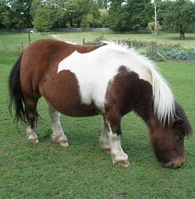

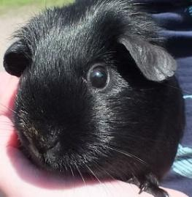
DARTFORD DISTRICT BEAVERS
SUNDAY 29 MARCH 2026
We’re excited to share that we’ve arranged a trip to Woodlands Farm on Sunday 29 March 2026. You’ll enjoy a guided tour packed with fascinating information about the animals and the important work of the Woodlands Farm Trust. There may even be a chance to hold, stroke, or gently interact with some of the animals.
Details are as follows:
Venue: Woodlands Farm, 331 Shooters Hill, Welling, Kent DA16 3RP
Time of Tour 10 a.m. Please ensure everyone has arrived by 9.45 a.m. at the latest. The tour will be about 2 hours, pick up will be at 1 p.m.
Cost: £2 per Beaver (this is for a snack and juice). This is to be in cash and handed to Leaders.
Important information:
- Leaders must attend to cover the ratios. If any Leaders are unable to attend, then please seek help from your Group, do not send your Beavers without Leaders.
- We need to be informed of any medical conditions or allergies as soon as possible so we can plan appropriately.
- No food should be brought to the farm. As this is a working farm, outside food can pose a risk to the animals. The District Beaver Team will provide snacks and juice.
- Parking at Woodlands Farm is very limited. Please advise parents and carers that it may be easier to park nearby and walk up the hill to drop off their young person.
- As the visit will take place outdoors, please ensure Beavers are dressed appropriately, including outdoor clothing and suitable footwear.

PLEASE LET ALICE KNOW AS SOON AS POSSIBLE OF ATTENDANCE AND NUMBERS (and if there are any medical/allergy information). Her email is alicelucas27@hotmail.com
We have been able to secure the tour at no cost, so any remaining funds will be donated to Woodlands Farm to support the care and upkeep of the animals.
